# Get Pi with Gaussian and Monta-Calo

Gaussian formula:

$$\begin{aligned}y=e^{-x^{2}}\#\left(1\right)\end{aligned}$$

Gaussian graph

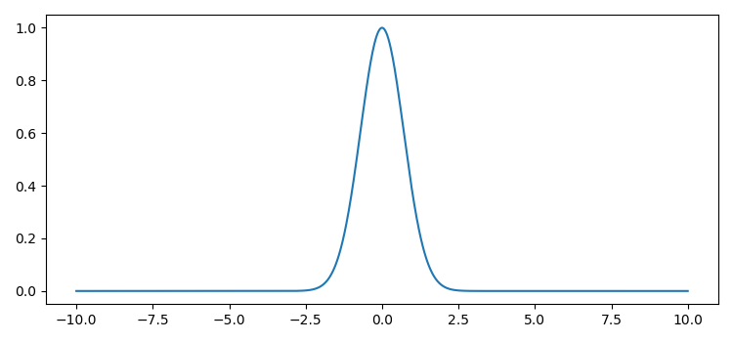

Figure 1：The graph of Gaussian Function

The square of Gaussian formula when x in ($-∞, +∞$) is $\sqrt{π}$

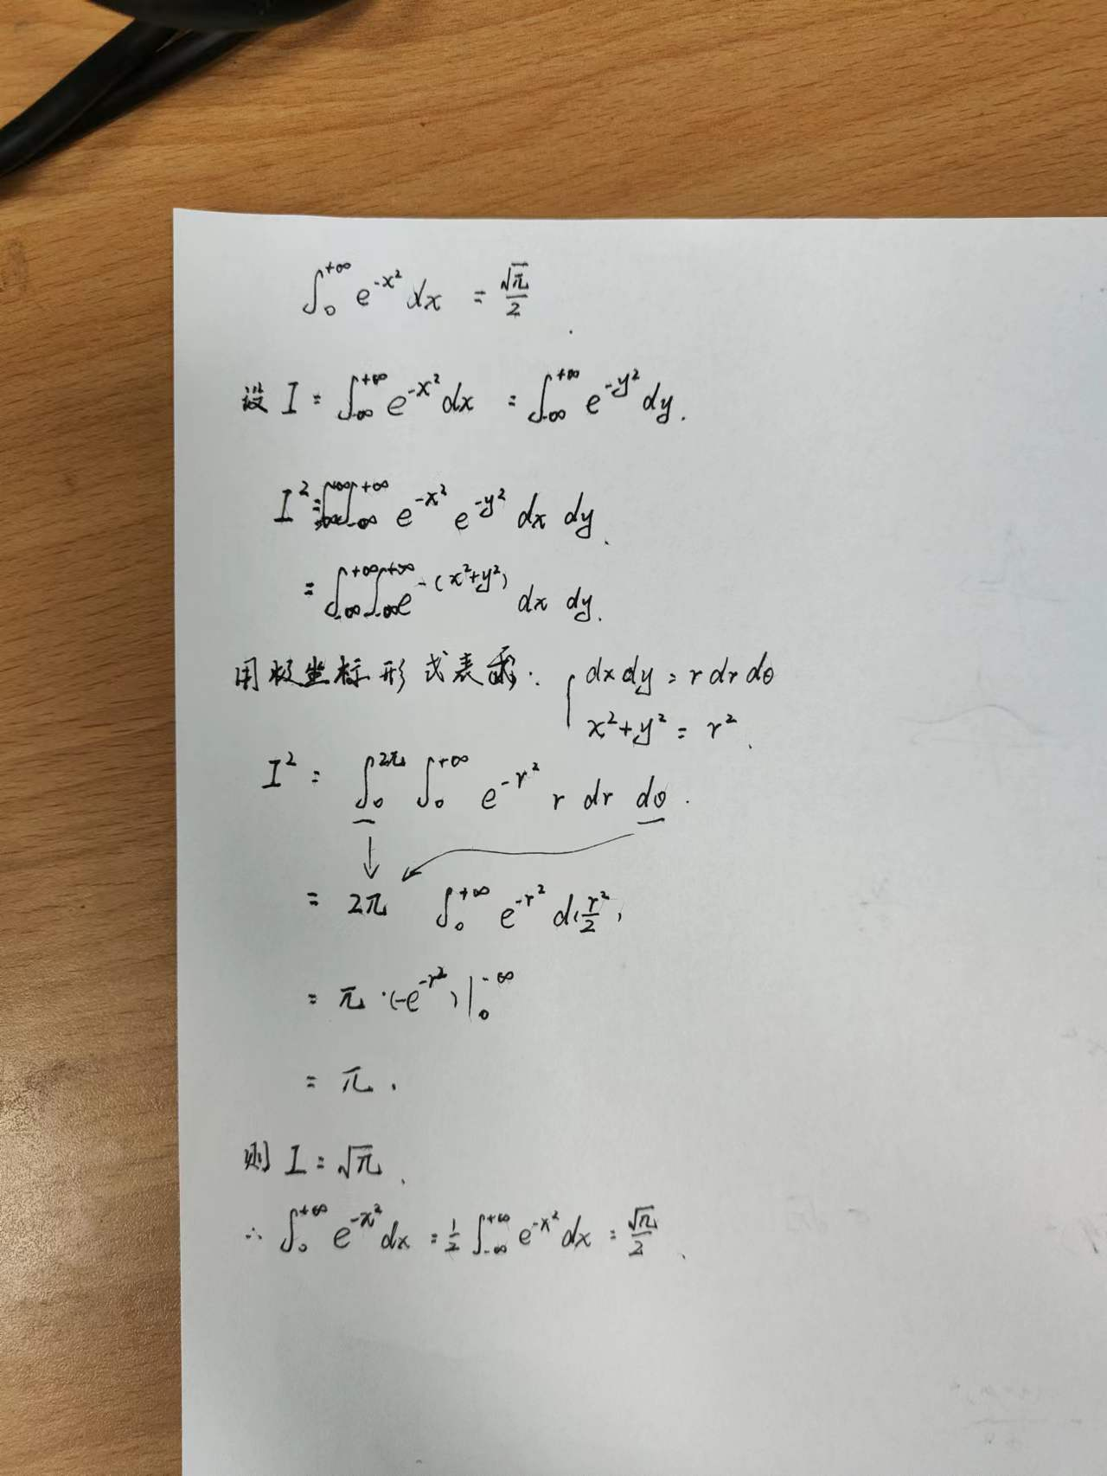

Figure 2：Solve sqaure of Gaussian

Confirm the boundary of simulating.



When the x is 10, $e^{-{10}^{2}}$ is much smaller than the x in 1

$$e^{-{10}^{2}}=3.72×{10}^{-44}≪1$$

So the x can be $x∈[0, 10)$

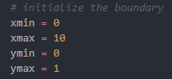

Simulate with Monta-Calo method and get pi using language pi

1. import random

2. import numpy as np

3. from time import perf_counter

4. from multiprocessing.dummy import Pool as ThreadPool

5.

6. # define the Gaussian Function

7. def gaussian(x):

8. return (np.exp(-x**2))

9.

10. # random throw dot and analyze

11. def simulate_dot_throwing(xmin, xmax, ymin, ymax):

12. global dot_in_area

13. x,y = random.uniform(xmin,xmax),random.uniform(ymin,ymax)

14. if y < gaussian(x):

15. dot_in_area = dot_in_area + 1

16. return 0

17.

18.

19. # counting program duration

20. start = perf_counter()

21.

22. # initialize the dot

23. dot_num = 100000000

24. dot_in_area = 0.0

25.

26. # initialize the boundary

27. xmin = 0

28. xmax = 10

29. ymin = 0

30. ymax = 1

31.

32. # Parallel Operation(error)

33. # pool = ThreadPool(4)

34. # pool.map(simulate_dot_throwing(xmin, xmax, ymin, ymax), range(1, dot_num))

35. # pool.close()

36. # pool.join()

37.

38. # Serial Operation

39. for ind in range(1,dot_num):

40. simulate_dot_throwing(xmin, xmax, ymin, ymax)

41.

42. # calculate the result of Pi

43. problem_space_square = (xmax - xmin) * (ymax - ymin)

44. dot_in_area_ratio = dot_in_area / dot_num

45. dot_in_area_square = dot_in_area_ratio * problem_space_square

46. PI = (dot_in_area_square * 2) ** 2

47.

48. duration = perf_counter() - start

49.

50. print(f'PI 的值为 : {PI}')

51. print("the duration is {:.5f}s".format(duration))

Run result





The relative error is 0.08%, and the accuracy is 99.919% > 99.9%. Thus this method is feasible.